Tracking variables

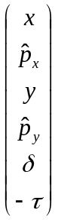

Terminology:

Design orbit:

Closed Orbit:

Reference Orbit:

[m] Positions in meters relative to the design orbit

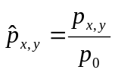 Canonical momentums normalized to the design momentum
Their relationship to the more intuitive orbit angles is given by the derivatives of the local Hamiltonian 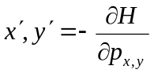. In the simplest case of a drift space: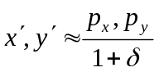

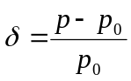 Momentum error normalized to the design momentum.

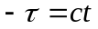[m] Differential Path length along the actual trajectory with respect to a particle on the
design orbit

